# **CTF Challenge: Checking URL - Using URLVoid**



# **1. Introduction**

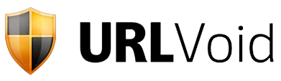

URLVoid collects and analyzes domain and IP reputation to help you understand and respond to internet threats. This challenge will introduce you to using URLVoid to gather information about a specific IP address.

# **2. Tools and Requirements**

Access to the internet and URLVoid

# **3. Scenario**

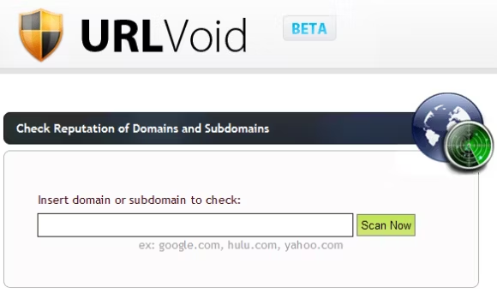

You are an ethical hacker tasked with gathering information about a specific IP address using URLVoid. Your job is to determine if the IP address has been flagged for any malicious activity and identify one recent activity associated with it.

# **4. Process to follow while performing CTF**

1. Visit URLVoid: [**https://www.urlvoid.com/**](https://www.urlvoid.com/)

2. Enter the URL [**https://octoperf.com/**](https://octoperf.com/) in the search bar and start the search.

3. Solve the CTF

# **5. Let’s Begin the Challenge**

**Questions**

**Flag 1: Is the IP address flagged for malicious activity?**

*Answer: No*

**Flag 2: What is the Ip address of the Targeted Website?**

*Answer: 108.156.22.42*

**Flag 3: What is the server Location?**

*Answer: US* ***OR*** *United States*

**Hint**

